# Proof-Level Load Testing of Bridges with Unknown Properties by Structural Identification

# Introduction

AASHTO Manual for Bridge Evaluation guides the inspection, analysis and calculations for determining load rating and for reviewing overload permit applications (AASHTO 2011). Load ratings in conjunction with inspection findings are expected to assist in determining a need for posting, strengthening or closure of a bridge. Load rating may be based on approximate or refined methods of analysis unless load testing is leveraged. In an approximate method of analysis, the bridge is modeled as a line-girder, with its share of loading assigned based on the distribution factors used in design. In the case of refined analysis, the stiffness of each element of a bridge needs to be explicitly represented in an analytical model. Finite element modelling is commonly employed for this purpose. It is well known that a FEM will require many assumptions regarding the geometry, materials, as well as boundary and continuity conditions of a bridge. Furthermore, each assumption will influence the results to some degree. Analysis results may further vary depending on the FEM selection, mesh size and configuration. Much greater errors should be expected if a bridge has unknown properties and deterioration. Obviously, without an analysis model that reflects the as-is dimensions, conditions, movement systems, continuity and supports, the results of load rating analyses may have unacceptable levels of uncertainty.

The 2014 National Bridge Inventory (NBI) included 610,749 bridges and culverts with a span greater than 20 ft. Of those structures, 145,890 bridges (23.9% of the NBI) were indicated as structurally deficient or functionally obsolete. Furthermore, more than a half of the inventory corresponds to local bridges owned by Cities, Townships and Counties, of which 24% are structurally deficient or functionally obsolete, making up a large proportion of the structurally deficient bridges. One of the reasons a bridge may be considered structurally deficient is posting. As of 2014, over 10% of this nation’s bridges and culverts are posted for less than their legal load (FHWA, U.S., Department of Transportation 2014). There are many reasons for posting a highway bridge, a common one of which is a perceived loss of bridge capacity due to deterioration and damage. Another reason is the inability to perform analysis because of missing documentation and/or unknown properties. For example, as of 2012, 36,076 bridges over waterways are identified as having unknown foundations (FHWA, U.S. Department of Transportation, 2012).

While the safety of our nation’s infrastructure is paramount, its mobility is also necessary for a thriving economy. Given the funding challenges faced by bridge owners, it behooves us to ensure that bridges are safely and accurately load rated and not unnecessarily posted. However, only 464 bridges are reported to have conducted load testing for rating (Hearn 2014). The implication is that many owners are not currently convinced of the cost- benefits of performing load rating by testing. Indeed, a safe and reliable field load test requires equipment, time and expertise that demand a substantial price—one that escalates even further when user costs are considered.

Section 8 of the AASHTO Manual for Bridge Evaluation (2011) provides guidance for load testing as an alternative to computing the load rating of a bridge solely by analytical methods. This Manual indicates two types of load tests available for bridge evaluation: *“diagnostic tests and proof tests. Bridges for which analytical methods of strength evaluation may significantly underestimate the actual strength are considered candidates for diagnostic load testing. Proof tests are used to establish the maximum safe load capacity of a bridge, where bridge behavior is within the linear-elastic range.”*

For proof tests, the Manual indicates that *“a bridge is subjected to specific loads, and observations are made to determine if the bridge carries these loads without damage. The proof test is terminated when: (a) a predetermined maximum load has been reached, or (b) the bridge exhibits the onset of nonlinear behavior or other visible signs of distress. Proof load testing of “known” bridges is called for when the calculated load ratings are low and the field testing may provide higher ratings. A second scenario is in the case of “hidden” bridges that cannot be load rated analytically because of insufficient information on their internal details and configuration. Bridges that are difficult to model analytically because of uncertainties associated with their construction and the effectiveness of repairs are potential candidates and beneficiaries of proof load testing.”*

# Concerns Regarding Current Proof Load Test Recommendations

The AASHTO Manual indicates that *“during a proof load test, the loads must be incremented and the response measured until the desired load is reached or until the test is stopped if the bridge response exhibits the start of nonlinear behavior or other visible signs of distress.”* It is envisioned that the proof load will correspond to a live load that will bring the bridge to a rating of 1. To provide the same level of safety inherent in LRFD, the live-load is increased by factor of typically 40%-55%.

The proof load testing procedures described by the Manual implicitly disregard the temporal dimension of the bridge system, assuming its capacity will remain constant. This, however, is extremely misleading since even if a bridge may pass a proof-load test one day it may fail under a lesser load at a later day. Destructive testing of decommissioned concrete or steel bridges to failure have revealed that bridges can resist loads in excess of 20 times that of a rating truck, governed by many mechanisms that are activated at various load levels, some of which may even make the bridge appear stiffer (Aktan and Farhey 1996).

It follows that performing proof-load testing of a bridge, requires a much greater understanding of a bridge than envisioning it as a line-girder. A test strategy should be developed based on analytical modeling of the structure and its actual 3D geometry, and the simulation of all the mechanisms that may govern the primary and secondary load transfer paths, and how any of the local member or connection details may affect these mechanisms. The kinematics of the bridge under various load levels will drive the instrumentation. Every component of the bridge system for which the capacity is being investigated must be modelled and subsequently instrumented (i.e. superstructure, substructure, foundations, etc.). It is critical to identify the mechanisms that contribute to a structure’s capacity in order to design the load increments, load positions, instrumentation, and data acquisition, as well as real-time communication and visualization such that the test may be performed safely and all relevant data gathered. Without the real-time feedback and visualization of critical bridge responses under load, safety may not be assured.

The capacity of a bridge is ultimately the capacity of the system, including the approaches, superstructure, substructure, foundations, soil and other attributes of the site. Each component will have an uncertain degree of contribution (possibly negative) to capacity. Thus all components along with their associated uncertainties must be considered even if not explicitly modeled. Structural identification (St-Id) concept provides the framework for capturing and considering these effects by integrating engineering heuristics, historical data and test results.

# The Structural Identification Concept and Application Guide

The term structural identification (St-Id) is an adaptation of the system identification concept from systems and control engineering to structural engineering of constructed systems. Douglas and Reid were early pioneers in applying the St-Id concept to characterize the lateral response characteristics of highway bridges by pull-release testing (1982). Gobel, Shultz and Commander leveraged a version of the St-Id concept for testing bridges under crawl loads since 1989 (1991). The writer has led an ASCE expert committee that issued a state-of-the-art report on St-Id (2013). The ASCE Committee formulated a 6-step iterative process, summarized below, to construct, calibrate and utilize a field-calibrated finite element model to capture, quantify and simulate the elements and mechanisms that influence the load effects such as intrinsic forces, live loads, corresponding internal actions and the responses of all the critical elements of the bridge system. The St-Id process ensures that a load test is planned, designed and performed competently and safely. Furthermore, it can be leveraged beyond the load rating to provide additional insight on the behaviors of bridge system and thus increase the value of the load test such as using it to design the sequencing of repair and/or retrofit measures. Each of the steps of St-Id is described in the following:

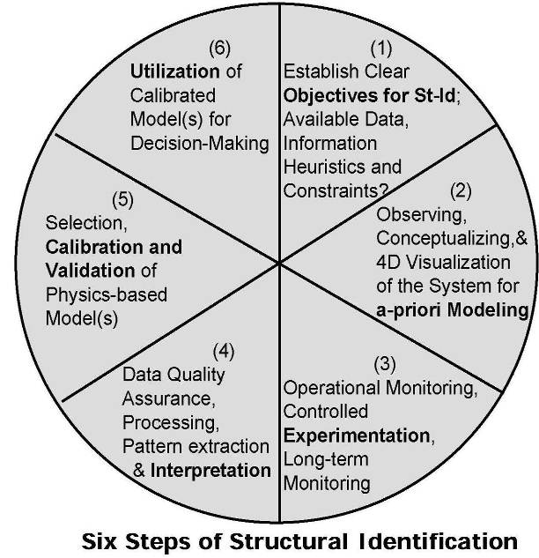

Figure : 6 Steps of Structural Identification

St-Id Step 1: Establish clear objectives for the St-Id effort and identify critical constraints and any missing information by meeting with the owner and visiting the bridge. Collect and evaluate the reliability of all available legacy data and information. Objectives that are in addition to load rating, such as how to effectively repair or retrofit the bridge, or an evaluation of the substructure and foundations for safety and scour or even for reuse, may be included.

St-Id Step 2: Observe the bridge system and measure selected responses under different operational and environmental conditions to conceptualize the system for a-priori modelling. This includes checking the dimensions, sampling and coring to verify material properties, scanning for rebar details, and boring to evaluate the soil conditions. The data and insight from these studies will help construct a 3D FE model that will simulate the important structural mechanisms. A model-builder must have experience with FE modelling, as well as an understanding of the kinetics and kinematics of the constructed system by actual on-site visits and observations. It is important to note that an infinite number of FE models can be constructed that are geometrically consistent with the structure, but may still fall short of accurately capturing the behavior of the structure. Given that the model should simulate all movements, restraints, joint and member deformations and mechanisms such as degree of composite action, and continuity between spans and or approaches as well as any soil pressures, selecting the appropriate mesh resolution and element choices becomes important.

Furthermore, boundary conditions and connectivity between elements must be considered and modelled effectively. The example FE model in Figure 2 & 3 was constructed by reducing the girders to beam elements and modelling the deck and sidewalk with shell elements. Geometry was retained by connecting the elements with link elements which enforce relationships between degrees of freedom of the connected nodes. Boundary conditions are modelled as rotational and translational springs. Because the superstructure was the component of interest in this case, the effects from the substructure, foundations and soil could be described by the boundary springs. If a rating of the substructure through load testing is desired, this portion of the structure must also be modeled.

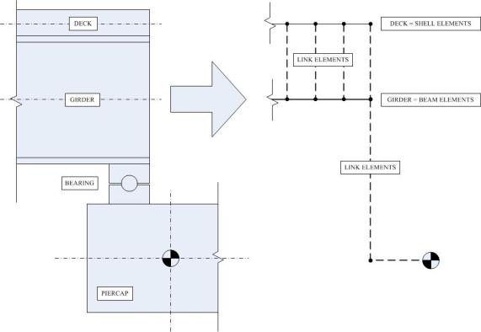

Figure 2: FE Characterization of Structural Components and Boundary Conditions of Superstructure

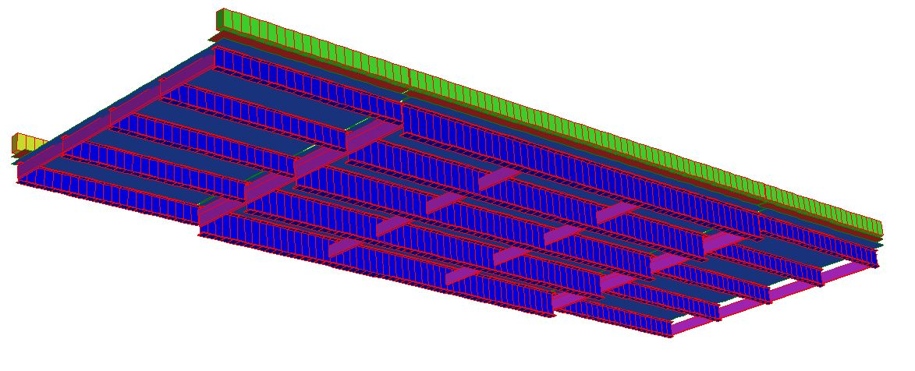

Figure 3: Example FE Model of Superstructure

The completed a-priori model serves for sensitivity studies to estimate failure modes and the bounds of critical responses that should be measured for a safe conduct of the test and for acquiring the data that will provide information to calibrate the model. This will help design the load levels and positions for the load test instrumentation and ensure that data captured during the load test will serve all of the objectives.

St-Id Step 3: Instrument the bridge structure according to the established objectives and based upon results from the *a-priori* model to perform operational monitoring of critical temperatures, strains, rotations or tilts and displacements. Even if the substructure is not to be rated as part of the load test, it is recommended the substructure be instrumented as well to monitor strain, tilt and displacement and provide a means of ensuring it does not experience distress during the test. For a typical bridge superstructure span, a sensor density corresponding to 12 to 24 sensors would be recommended as shown in Figure 4. It is important to have redundancy and a variety of sensors with appropriate gage lengths (0.5 – 6 inches), sensitivity and accuracy.

|  |  |  |
| --- | --- | --- |
| Figure 4: Superstructure Instrumentation Example | | |
| Figure 5: Strain Gages on Girder | Figure 6: String Potentiometer | Figure 7: TML's Measure Joint Movement |

The load test is performed by positioning a number of trucks to incrementally increasing load levels up to the target proof load level. It is desirable to repeat operational monitoring following the load test. The load test will require extensive planning, rehearsals and execution by specialized engineers who will monitor bridge responses in real-time as trucks are positioned for increased increments of load. If the structure begins to show signs of distress (i.e. non-linear behavior), testing must be terminated. Based on limited field experience, target loads of at least 2 to 2.5 times the legal load may be warranted during a proof load test in order to activate all of the critical response mechanisms of a bridge. This is quite different from the recommendations of the AASHTO Manual suggesting load levels of about 1.5 times the rating load. If a bridge exhibits any signs of distress such as cracking or yielding at less than 2.5 times the rating load, such a bridge should indeed be posted. It is desirable to include strain and tilt measurements of the substructures during such a test.

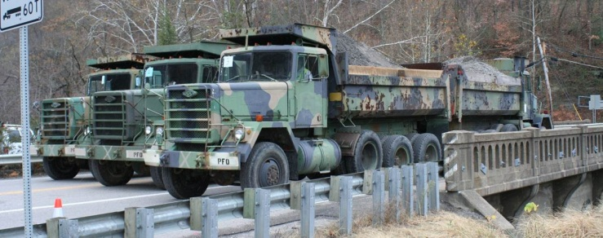

Figure 8: Proof Level Loading of Arch Span Figure : Proof Level Loading of T-Beam Bridge

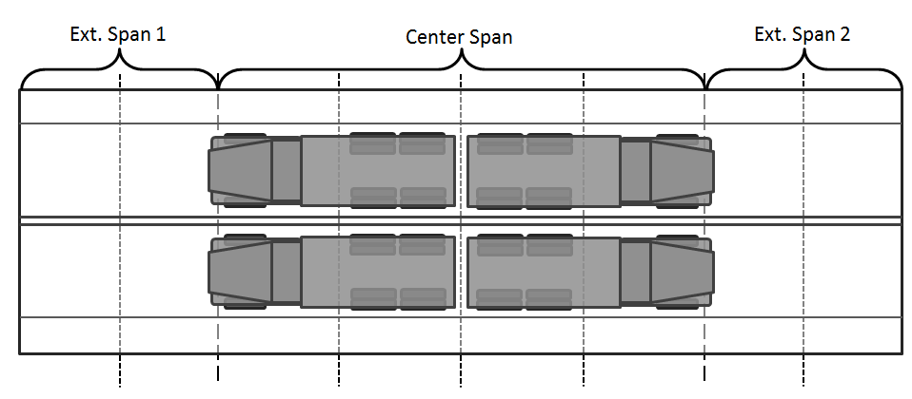St-Id Step 4: The metadata, operating and proof load test data as well as images are evaluated, synchronized and data quality is verified before archival. Data is visualized and interpreted for patterns and response quantities. This will start during the experiment in-situ to identify and rectify issues and mistakes. For example, real-time data interpretation should be compared to model predictions and any discrepancies should be evaluated to determine if the predicted failure modes and ultimate capacity should be revised along with subsequent load cases. Especially, the linearity of the structure and the critical elements should be continuously monitored to identify members that may approach cracking or yielding.

Figure : Proof Level Load Position

Figure : Displacement under Proof Level Load

St-Id Step 5: Modify, validate and finalize the a-priori FE model before calibrating it with selected data sets from the operational monitoring and load test. A critical issue is making sure that the model is complete (i.e. the model can explicitly simulate all of the critical loading and response mechanisms and especially the measured kinematics at the supports and boundaries of the bridge). The bridge dynamic characteristics such as frequencies and mode shapes that may be extracted from operating responses, in addition to displacements, tilts and strains under known-measured tire loads and at different positions will constitute various data sets to calibrate and then validate the FE model. There will always be a larger number of parameters to calibrate (material properties and dimensions of all elements as well as all joint, bearing, connection and boundary properties, including those at foundations) than the number of measurements, therefore one cannot expect a unique calibrated model. However, if a model is calibrated to mimic all of the measured input-output or load-response relations of the bridge with acceptable level of discrepancy, it may be considered suitable to serve the objectives of St-Id.

Figure : Strain Response under Proof Level Load

St-Id Step 6:Leveraging the calibrated model for the objectives of St-Id. The calibrated model is especially powerful when used to identify mechanisms contributing to the bridge’s actions and the corresponding capacity. There are numerous mechanisms providing stiffness and contribute to the capacity of a bridge at the time of load testing that the owner may not wish to include or that may diminish under different environmental conditions or after several years. These may include but are not limited to: composite action between deck and girders, diaphragms, concrete and soil stiffness and conditions, contributions of sidewalks and barriers, locked movement systems, arching action of a slab, etc.

Although the FE model is foremost used to compute a load rating, it can be further leveraged to simulate other loading scenarios and to gain a better understanding of the structural characteristics of the bridge. A more detailed description of the structural identification process can be found elsewhere, but the above discussion sufficiently summarized the process.

# Case Studies

Since the 1980’s, the St-Id has been performed on several dozens of actual bridges, some of which had unknown foundations. Rating results from these bridges, covering concrete T-Beam, concrete arch and RC deck on steel girder bridges are presented below.

|  |  |
| --- | --- |
| Figure 13: Concrete Arch Bridge (00000000054A035) | Figure 14: T-Beam Bridge (000000000005085) |
| Figure 15: T-Beam Bridge (00000000010A140) | Figure 16: Steel Stringer Bridge (00000000010A055) |

For each of the bridges listed in Table 1, load ratings were first computed by the line-girder model while a 3D FE model of each bridge was also constructed. The results of the tests were used to field-calibrate the FE models following the St-Id guidelines presented above. These “field-calibrated” 3D FE models were then used to calculate the dead load and live load demands, and a second load rating listed under FEM was computed.

Table 1: Load Rating Comparison

|  |  |  |  |  |  |
| --- | --- | --- | --- | --- | --- |
|  | **NBI Structure Number** | **Rating Factors** | | **Comparison** | |
|  | AASHTO | FEM | AASHTO/ FEM | Percent Increase |
| T-Beam | 000000000015156 | 0.92 | 3.25 | 3.53 | 253% |
| 000000000010570 | 1.27 | 3.18 | 2.50 | 150% |
| 000000000000134 | 1.22 | 3.35 | 2.75 | 175% |
| 000000000005085 | 1.01 | 5.62 | 5.56 | 456% |
| 00000000010A140 | 1.2 | 3.3 | 2.75 | 175% |
| Arch | 00000000054A035 | 1.16 | 5.38 | 4.64 | 364% |
| Steel | 00000000010A055 | 2.14 | 3.55 | 1.66 | 66% |

As can be seen from Table 1, rating factors computed using a field-calibrated FE model are consistently and significantly greater than those computed using the single line girder model. ***Indeed, the seven structures, which the authors rated with calibrated FE models, exhibited an average increase of 231% over the AASHTO rating after all load and capacity factors were applied.*** This is due to the fact that the single line girder is too conservative as it assumes the bridge carries its dead and live loads only by bending and shear in its girders. The 3D FE model includes many additional distribution mechanisms such as the RC deck functioning as a plate and a diaphragm, working compositely with the girders (due to mechanical or chemical bond), and the lateral diaphragms and cross braces, any wind-bracing, boundary and bearing fixity, and possible lateral confinement from approach slabs at the abutments along with any confining soil pressures. The process of calibrating the FE model with load test data ensures that these mechanisms are accurately parameterized.

While the FEM load rating factors are greater than the line girder ratings, this cannot be generalized as the rule. At this time of scarce resources, the availability of ubiquitous computing and the need to identify which structures truly require posting, the value of proof-level load testing of select bridges is clear. The critical question is how to perform such tests safely and properly so that we may learn about actual bridge behavior and the mechanisms that actually contribute to the load carrying capacity of a bridge, therefore informing the design and the load rating of other bridges.

# Conclusion

Bridges that cannot be load rated due to missing information, or load rated at less than the legal loads and posted, may in fact possess sufficient load capacity and significant remaining life, depending on their design and construction, even if they may appear to be at the end of their useful life. It is possible to identify these bridges by properly designed and executed proof-level load testing and rating. While proof load testing in 2015 should not be rocket science, it does require experience and resources to design and perform field experiment and should include 3D FE modeling and simulation along with a heuristic understanding of bridge behavior. The value of such tests is not just the removal of posting for a bridge, but a better understanding of how bridges of certain design and construction characteristics (i.e. a family or statistical population) that carry their loads by similar mechanisms, can be better evaluated and load rated.

The structural identification concept provides a framework that guides load testing, helping to ensure that it is designed and conducted safely, the resulting load rating computed accurately and with due consideration of the uncertainty of contributing mechanisms. The cost of a properly executed proof-load test and load rating of a typical bridge span by following the structural identification methods described in this brief may reach about $150K. This cost may be significantly reduced by streamlining the modeling, instrumentation and load testing process and utilizing advanced technologies (i.e. wireless sensors, high-resolution photogrammetry, etc.).

# Works Cited

AASHTO. "The Manual for Bridge Evaluation." AASHTO, Washington, DC., 2011.

Çatbaş, Necati F., Tracy Kijewski-Correa, and A. Emin Aktan. "Structural Identification of Constructed Systems." *Reston (VI): American Society of Civil Engineers.* 2013.

Douglas, Bruce M., and Wayne H. Reid. "Dynamic tests and system identification of bridges." *Journal of the Structural Division.* Vol. 108. no. ST10. American Society of Civil Engineers, 1982.

FHWA, U.S., Department of Transportation. *Bridges by Posting Status (2014).* 12 31, 2014. http://www.fhwa.dot.gov/bridge/nbi/no10/posting14.cfm.

Goble, G., J. Schulz, and B. Commander. "Load prediction and structural response." *Report to FHWA by Department of Civil and Architectural Engineering, University of Colorado.* Boulder, Colorado, 1991.

Hearn, George. "State Bridge Load Posting Processes and Practices." *Synthesis 453.* Transportation Research Board, 2014.

Mlynarski, Mark, Wagdy Wassef, and Andrzej Nowak. "A Comparison of AASHTO Bridge Load Rating Methods." *Report 700.* Transportation Research Board, 2011.

Olson, D. L., F. Jalinoos, and M. F. Aouad. "NCHRP Final Report 21-5: Determination of Unknown Subsurface Bridge Foundations." Federal Highway Administration, n.d.

Turer, A. "Condition Evaluation and Load Rating of Steel Stringer Highway Bridges Using Field Calibrated 2d-Grid and 3D-FE Models." *Dissertation for Doctorate of Philosophy in the Department of Civil and Environmental Engineering of the College of Engineering.* University of Cincinnati, 2000.

**Contributors to the Tech Brief:** Frank Jalinoos, H. Ghasemi, J. Braley, A. E. Aktan, F. Moon, I. Bartoli, K. Sjoblom

General Comments

Introduction reads as if the comparison is between AASHTO Line girder methods versus FEM method. In fact, the paper has significantly more valuable material, for example comparison between 6 approaches for load rating, listed in comment 39 earlier. Hence, the introduction should be modified to highlight this comparison. It will be definite contribution.

The biggest drawback of the tech brief is that it proposes using St Id as a prerequisite to performing proof load testing, which is counter to the goal and objectives of the proof load testing concept: find the load capacities of bridges whose capacities cannot be determined through analytical model. The authors haven’t also made the case of ST ID, since improvements in load rating through their approach is because of calibration of the analytical model using load test data. It will be interesting to see the improvement in load rating without calibrating the FEM model by load test data. ST ID tool (FEM based, including model updating) is not a new tool and can be used for a subset of load tested bridges for which DOTs or owners desire more reliable analytical model. The tech brief will be a good contribution if authors rewrite the tech brief by keeping this objective.

Aktan, A. E. and D. N. Farhey (1996). "Condition and Reliability Assessment of Constructed Facilities." Special Publication **162**.